**Exam Questions – With Solutions**

**Briefly describe the behaviour of the y values for the following, given the behaviour of the x values: y = $\frac{1}{x}$, as x → –∞**

y → 0

**A parabola with equation $y=a(x-b)(x+c)$ has turning point (2, –8) and y-intercept (0, –6). The constants a, b and c are all positive.**

**[a] Determine the values of the positive constants a, b and c.**

y = a(x–2)2 – 8

–6 = a(–2)2 –8 🡪 a = 0.5

y = 0.5(x–2)2 – 8 = 0.5(x+2)(x–6)

a = 0.5, b = 6, c = 2

**[b] The parabola is translated 10 units left and 5 units downwards. Determine the equation of the transformed parabola in the form $y=a(x-p)^{2}+q$.**

y = 0.5(x+10–2)2 – 8 – 5

y = 0.5(x+8)2 –13

**An obtuse-angled triangle ABC has a = 36cm, c = 52cm and an area of 748cm2.**

**[a] Sketch a triangle to show this information.**

B

52cm

36cm

A

C

748cm2

**[b] Determine the size of ∠B.**

748 = $\frac{1}{2}$ x 52 x 36 x sin(∠B)

∠B = 53.05° 🡪 But it’s obtuse so ∠B = 180 – 53.05 = 126.95°

**[c] Show that b ≈ 79cm.**

b = $\sqrt{{52}^{2}+ {36}^{2}-2 x 52 x 36 x cos⁡(126.95)}$ = 79.06 ≈ 79

**[d] Show that ∠C ≈ 32°.**

$$\frac{sin(∠C)}{52}= \frac{sin⁡(126.95)}{79}$$

sin(∠C) = 0.526 🡪 ∠C = 31.74° ≈ 32°

**A small weight, attached to the bottom of a spring, oscillated up and down. The distance, d cm, of the weight from the top of the spring after t seconds can be modelled by:**

$$d=45+35\sin{(\frac{3πt}{4}})$$

**[a] Sketch the graph on the axes below for 0 ≤ x ≤ 3.**

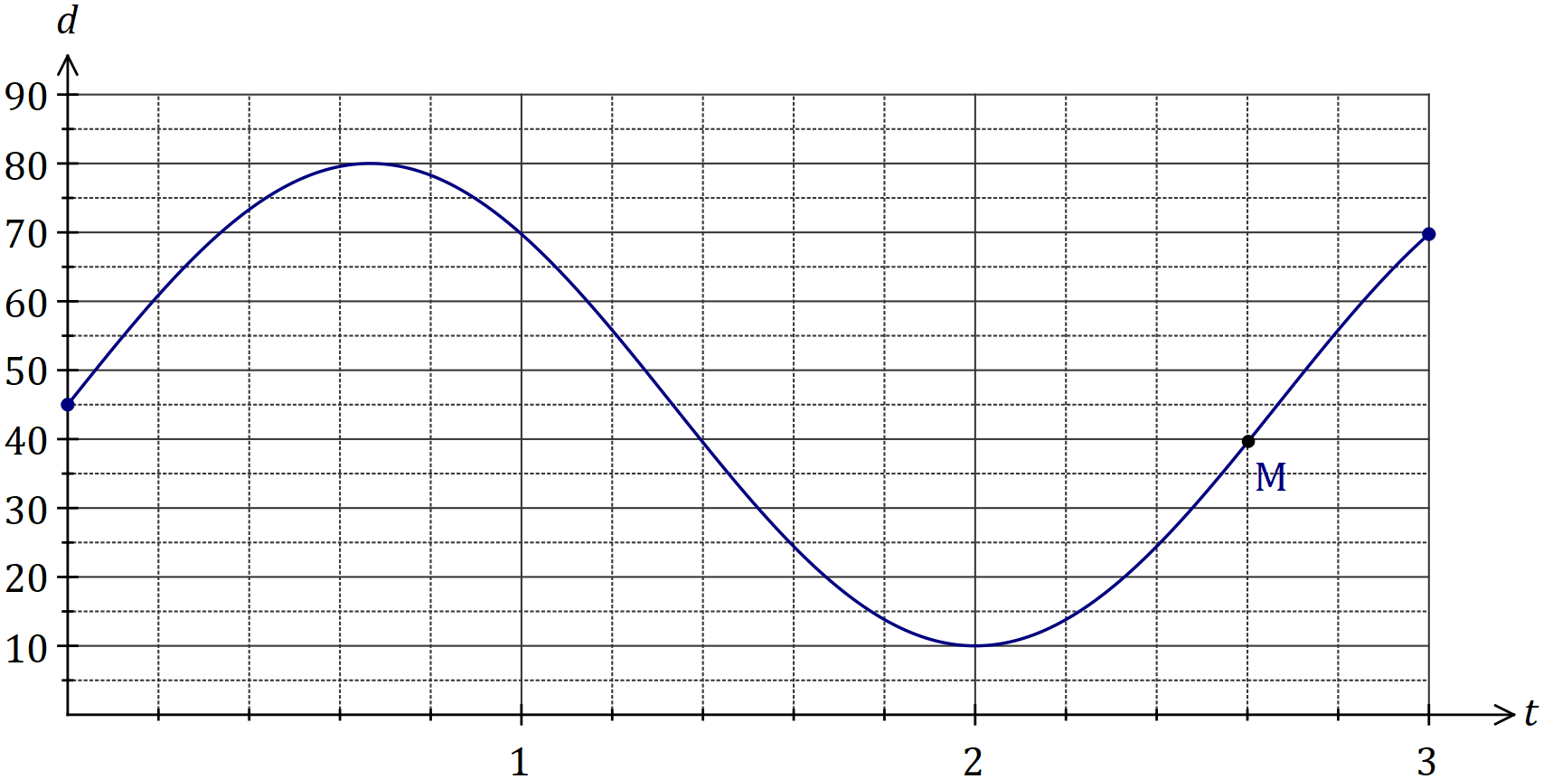

**[b] Mark on your graph point M, where the weight is 40cm from the top of the spring and moving downwards.**

Hint: As d gets larger, the spring is moving downwards, so M is as d gets larger.

**[c] Determine**

**(i) The maximum distance of the weight from the top of the spring.**

Maximum distance = maximum value for d = 80cm

**(ii) The time taken for the spring to return to its initial position.**

b = $\frac{3π}{4}$

Period = $\frac{2π}{b}$ = $\frac{2π}{\frac{3π}{4}}$ = 2π x $\frac{4}{3π}$ = $\frac{8}{3}$

Time to return to initial position is half the period so t =0.5 x $\frac{8}{3}$ = $\frac{4}{3}$ = 1.35 seconds

**(iii) The distance moved by the weight between t = 1 and t = 2.**

d(1) – d(2) = 69.75 – 10 = 59.75cm

**In shape OABCD below, ∠AOB = 126° and AC, BD are diameters of the circle with centre O and radius 35cm.**

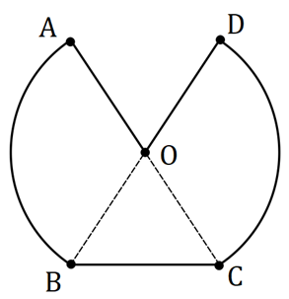

**[a] Calculate the perimeter of OABCD.**

AB + DC = 2 x 35 x $\frac{126π}{180}$ = 153.94cm

BC = $\sqrt{{35}^{2}+{35}^{2}-2 x {35}^{2} x cos⁡(\frac{360-2 x 126}{2})}$

= 31.78cm

AO + DO = 35 x 2 = 70cm

Perimeter = 153.94 + 31.78 + 70 = 255.72cm

**[b] Calculate the area of OABCD.**

AOB + DOC = 2 x x 352 x = 2693.94cm2

BOC = x 352 x sin() = 495.52cm2

Area = 2693.94 + 495.52 = 3189.cm2

**Let a = sin50 and b = cos100.**

**Give your answers to the following in terms of a and/or b.**

**[a] Write an expression for**

**(i) sin130**

sin130 = sin50 = a

**(ii) cos80**

cos80 = – cos100 = –b

**[b] Determine an expression for cos130.**

cos2130 + sin2130 = 1

cos2130 = 1 – a2

cos130 = $±\sqrt{1-a^{2}}$

But cos130 is negative 🡪 cos130 = $-\sqrt{1-a^{2}}$

**[c] Determine an expression for tan130.**

tan130 = $\frac{sin130}{cos130}$ = $\frac{a}{\sqrt{1-a^{2}}}$

**The graph of y = f(x) is shown below, where f(x) = is shown below, where f(x) = sin(x+c) and c is a constant.**

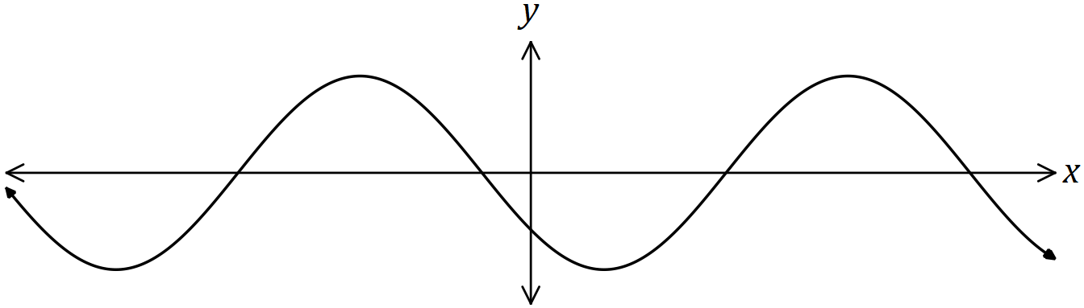

**Explain how to obtain the graph of each function below from the graph of f(x), given that a and b are also constants.**

**[a] y = sin(x+a).**

sin(x+c) 🡪 sin(x+a) Subtract c and add a.

sin(x+c–c+a) = sin(x+a)

sin(x+c–(x–a) = sin(x+a)

Translate horizontally by (c–a) units.

**[b] y = cos(x+b).**

sin(x+c) 🡪 cos(x+b)

sin(x+c) = cos(x+c $-\frac{π}{2}$) Subtract c and add b.

cos(x+c+ $\frac{π}{2}$– c+b) = cos(x+b)

cos(x+c–($-\frac{π}{2}$ +c–b) = cos(x+b)

Translate horizontally by (c–b $-\frac{π}{2}$) units.

**The circle shown has centre O and diameter AC of length 50cm. Determine the shaded area given that 2 x ∠AOB = 3 x ∠BOC.**

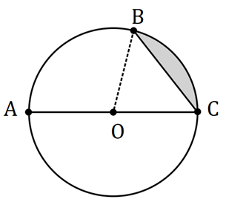

∠AOB + ∠BOC = 180°

∠BOC = $\frac{2}{3}$ x ∠AOB

CAS simultaneous 🡪 ∠BOC = 72°, ∠AOB = 108°

Area = x 252 x – x 252 x sin() = 95.49cm2

**A sector of a circle has a perimeter of 112cm and an area of 735cm2. Determine the radius of the circle.**

x r2 x θ = 735

r x θ + 2r = 112

CAS simultaneous 🡪 r = 21cm, 35cm

**Line L has equation $\frac{x}{4}+ \frac{y}{5}=1$.**

**[a] Determine the equation of line P that’s perpendicular to L and passes through the point with coordinates (50, 4).**

Line L: y = $-\frac{5}{4}$ x + 5

Line P: y = $\frac{4}{5}$ x + c

Substitute (50, 4) 🡪 4 = 40 + c 🡪 c = –36

**[b] Determine the coordinates of the point of intersection of L and P.**

Line P: y = $\frac{4}{5}$ x – 36

Line P = Line L 🡪 x – 36 = $-\frac{5}{4}$ x + 5

$\frac{41}{20}$ x = 41 🡪 x = 20

When x = 20, y = –20 🡪 (20, –20)

**A running track has circular ends of radius 100m and two straight, parallel sides $PQ$ and $RS$ that are both 120m long, as shown below. Determine, to the nearest metre, the total length of the track.**

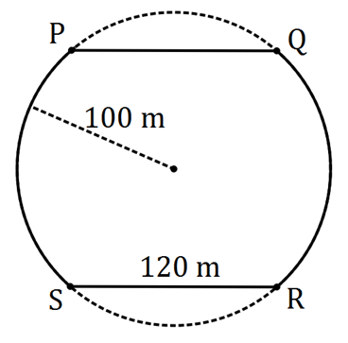

1202 = 1002 + 1002 – 2 x 1002 x cos(x) 🡪 x = 1.287 radians

$\frac{2π-2 x 1.287}{2}$ = 1.855 radians

PS + QR = 2 x 100 x 1.855 = 370.92m

Perimeter = 120 x 2 + 370.92 = 610.92m ≈ 611m

**The diagram shows a circle with centre $O$ and diameter $BC$, and an equilateral triangle ABC. Determine the exact fraction of the area of the circle that lies outside the triangle.**

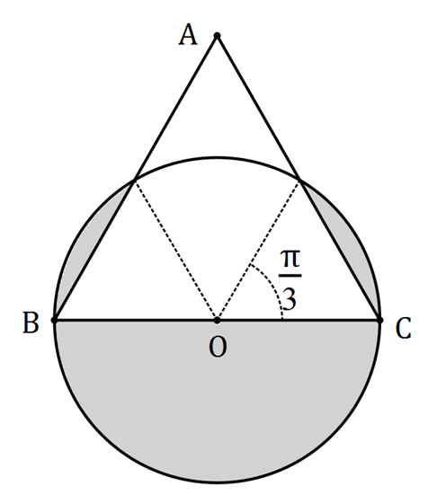

Area outside = x π x r2 + 2 x ( x r2 x – x r2 x sin ) = + –

=

Fraction = $\frac{Outside area}{Circle area}$ = $\frac{3πr^{2} + 2r^{2}π - 3\sqrt{3}r^{2}}{6}$ x $\frac{1}{πr^{2}}$ = $\frac{r^{2}(3π + 2π - 3\sqrt{3})}{6}$ x $\frac{1}{πr^{2}}$ = $\frac{3π + 2π - 3\sqrt{3}}{6π}$

= $\frac{5π-3\sqrt{3}}{6π}$

**Line A and Line B in the x-y plane intersect at 90° at the origin. Line A has a slope of $\frac{1}{3}$. Point (2, –6) is the midpoint of line segment CD which is parallel to Line A. Given that the x-value of C is –1, find the coordinates of point D.**

2 = 🡪 x = 5

= –6 🡪 y2 + y1 = –12

= = = 🡪 y2 – y1 = 2

y2 + y1 = –12

P(D) = (5, –5)

2y2 = –10 🡪 y2 = –5

y2 – y1 = 2

Use gradient: = 🡪 y2 – y1 = 2 🡪 –5 – y1 = 2 🡪 y1 = –7 🡪 P(C) = (–1, 7)

**Complete the square to find the roots of the quadratic function f(x) = 5x2 – 7x + 1.**

5x2–7x + 1 = 5(x2 – x + )

= 5(x2 – x + – + )

= 5(x – )2 –

5(x – )2 =

(x – )2 = x =

x – = = ±

x = ± =

**The current A (amperes), varies inversely to the resistance R (ohms) in an electric circuit. When the resistance is 12 ohms, the current is 0.5 amperes. Determine the effect on R if A is increased by 35%.**

R = $\frac{6}{A}$

Increased by 35%: R = $\frac{6}{0.5 x 1.35}$ = 8.89

Effect = $\frac{12-8.89}{12}$ x 100 = 25.9% 🡪 Therefore, R decreases by 25.9%

**A sector OPQ of a circle with centre O is drawn below. The radius of the circle is 18 cm and angle POQ is 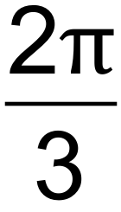 radians. The tangents to the circle at the points P and Q meet at point R. 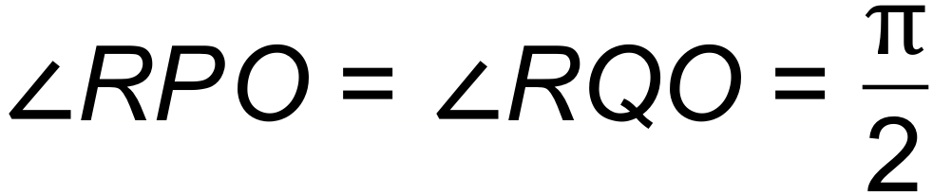. Find the exact area of the shaded region.**

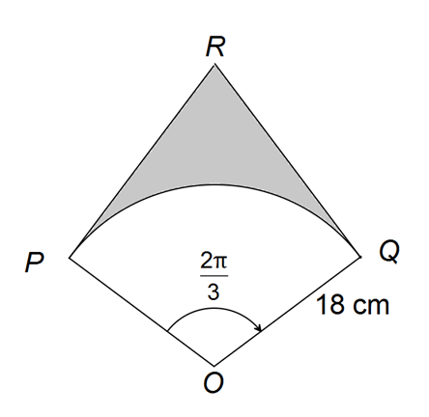

tan() = 🡪 PR = 18tan($\frac{π}{3}$)

Triangle area = $\frac{1}{2}$ bh = $\frac{1}{2}$ x 18 x 18tan($\frac{π}{3}$)

Kite area = 2 x $\frac{1}{2}$ x 18 x 18tan($\frac{π}{3}$) = 18 x 18tan($\frac{π}{3}$)

Sector area = x 182 x

Shaded area = (18 x 18tan()) – ( x 182 x ) = 324 – 108π = 108(3 $\sqrt{3}$– π)

**The circle with centre A(5, 8) touches the 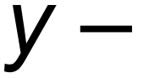axis as shown below.**

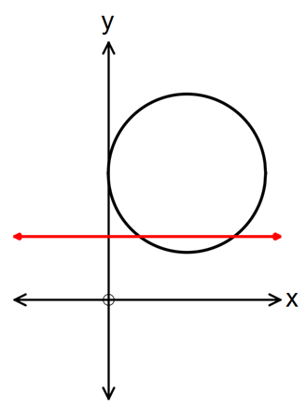

**The line y = 4 intersects the circle at point M and N.**

**[a] Determine the length of the chord MN.**

(x – 5)2 + (y – 8)2 = 25 🡪 substitute y = 4 🡪 x = 2, x=8 🡪 6 units

**[b] Find the area of the minor segment formed between MN and the circle.**

62 = 52 + 52 – 2 x 52 x cosθ 🡪 θ = 1.287 radians

x 52 x 1.287 – x 52 x sin(1.287) = 4.0875 units2

**The diagram below has an arc, PQ, of a circle with centre O and radius r.**

**PR is perpendicluar to OQ. Angle POQ = 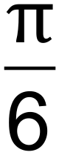 radians.**

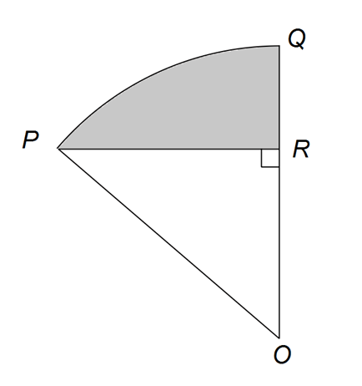

**[a] Show that the area of triangle POR = $\frac{r^{2}\sqrt{3}}{2}$ in terms of r. (Hint: First find expressions for OR and RR in terms of r).**

sin() = 🡪 PR = $\frac{r}{2}$

cos() = 🡪 OR = $\frac{r\sqrt{3}}{2}$

Triangle area = $\frac{1}{2}$ x $\frac{r\sqrt{3}}{2}$ x $\frac{r}{2}$ = $\frac{r^{2}\sqrt{3}}{8}$

**[b] If the shaded area is cm2, calculate the value of r.**

Shaded area = sector area – triangle area

= x r2 x –

CAS 🡪 r = 2, r = –2 (reject x = –2)

r = 2

**The perimeter of a sector, with central angle θ radians in a circle of radius r, is 12 cm**

**[a] Express θ in terms of r.**

12 = rθ + 2r

θ = $\frac{12-2r}{r}$ = $\frac{12}{r}$– 2

**[b] Show that the area of the sector is 6r – r2.**

x r2 x ( – 2) = – r2 = 6r – r2

**[c] Determine the area of the sector if θ = 1.**

$\frac{12}{r}$– 2 = 1

12 – 2r = r

–3r = –12

r = 4

x 42 x 1 = 8cm2

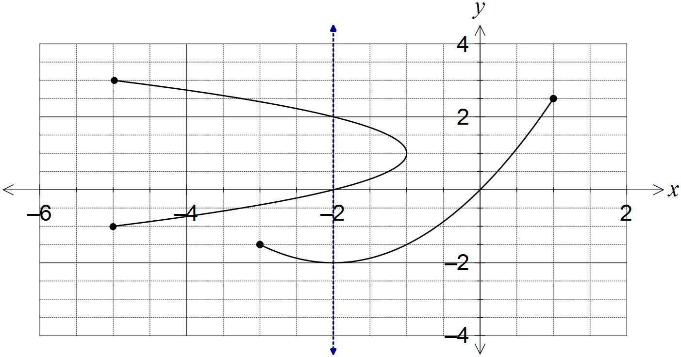

**The relation can be expressed in the form y2 = ax + by – 2. Determine the values of the constants a and b.**

When x = 0, y = 0, 2

When y = 0 🡪 02 = –2a + b(0) – 2 🡪 a = –1

When y = 2 🡪 22 = –2(–1) + 2b – 2 🡪 b = 2

**In triangle ABC, ∠BAC, AC = 18.4 cm and BC = 15 cm.**

**Determine the largest possible area and smallest possible perimeter of this triangle.**

B

15

18.4 cm

50°

C

A

= 🡪 ∠B = 70°, 110°

∠C = 180 – 50 – 70 = 60° or 180 – 50 – 110 = 20°

Largest area = $\frac{1}{2}$ x 18.4 x 15 x sin60 = 119.51°

AB2 = 18.42 + 152 – 2 x 18.4 x 15 x cos20 cos60 < cos20

AB = 6.70

Largest perimeter = 15 +18.4 + 6.70 = 40.10cm